

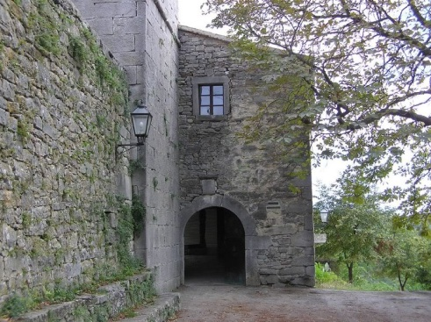
Departure from Opatija towards tunnel Učka that leads to the Istrian peninsula.
Excursion to the central Istria, to the smallest town on Earth. Passing through old stone door that witness a thousand-year old life that took place there. Hum is also one of the most famous center of Glagolism. The evidence can be found in numerous monuments inside and outside the city.
After walk through the city streets we continue the journey to Roč. On the way we make a break for lunch. Kolinasi tavern is a typical Istrian tavern with a fireplace, stone walls and traditional sitrian couisine.
After lunch the journey continues to Roč which is one of the most important centrals of Glagolism. It is protected as a cultural monument. Especially interesting are the city walls with 5 fortresses, two city doors, and three churches.
After Roč continuing towards Opatija, and getting there in the evening hours
Excursion includes: modern tourist bus, tourist guide, lunch in the tavern

